Par-Troy West Little League

2024 Season Program

Be Proud of Our Children
Be Proud of Our Town
Be Proud of Our League

PTWLL would like to thank the following
sponsor for providing the food for Opening Night:

1057 Route 46

Parsippany NJ 07054

973-263-5005

Table of Contents

 | Page #
President’s Message | 4
Board of Directors | 5/6
Our Commitment to Safety | 7
Frequently Asked Questions | 8
Tee Ball League Schedule | 9
Tee Ball League | 10
Farm Baseball League Schedule | 11
Farm Baseball League | 12
Minor League Baseball Schedule | 13
Minor League Baseball | 14
Major League Baseball Schedule | 15
Major League Baseball | 16
Junior League Baseball Schedule | 17
Junior League Baseball | 18
Little League Softball Division | 19
Farm League Softball & Schedule | 20
Minor League Softball & Schedule | 21
Major League Softball & Schedule | 22
Junior League Softball | 23
Important Information & Events | 24
Team Sponsors | 25
Little League Pledge | 26

President’s Message

Dear Friends of Par-Troy West,

The Board of Directors and I would like to welcome you to the Par-Troy West Little League (PTWLL) Baseball and Softball 2024 Season. This season marks the 71st year that Par-Troy West has had the privilege of serving the children of Parsippany.

Through the 300+ children in our programs combined in both baseball and softball. The Board of Directors continues to work hard and put in many volunteer hours to make sure that your child's experience will be fun filled and enjoyable.

I want to thank all our Board members, volunteers, sponsors and friends, who give their time and support to help make our program run. Without them, we could not operate. It's because of everyone's combined efforts that the Par-Troy West program is such a great success. That is why I and other Board members urge you to please help out and volunteer in any capacity you can. The success of a Little League program depends on the amount of dedicated volunteers we can get to assist.

We would also like to thank the Township of Parsippany, The Parsippany Recreation Department and The Board of Education, for the opportunity to use the ball fields in town and at the schools during the season. Their support helps ensure that all Little Leaguers have a place to play.

This coming season should prove to be another exciting one and we look forward to all the children having fun and hope to see you all out there!

Sincerely,

Frank A. Neglia
President
Par-Troy West Little League

WEB Page: https://partroywestlittleleague.teamsnapsites.com/
Par-Troy West Little League

2024 Board of Directors

2024 Executive Board
Name | Official Title | Email
Frank Neglia | President  Corporate Sponsors  Director, Junior/Senior League | partroywest@gmail.com
Darren Dragone | VP Baseball & Administration | dependablemortgage11@gmail.com
Jerry Vecchia | VP Softball/  Equipment & Uniforms | ptwsoftballcoach@gmail.com
Marc Davis | League Treasurer  Purchasing agent/Equipment and Uniforms | midavis03@yahoo.com
Sandra Neglia | Player Agent  Administrator, Sponsors & Trophies/  Umpire Scheduler, / Fund Drive Coordinator  Administrator, Clinics | sandra4a@aol.com
Joelle Rosetti | League Secretary & Information Officer  Webmaster - PTWLL website  Manager, Social Media  Pictures/scheduling, etc. | jojo5er@yahoo.com
Elena Fletcher | Safety Officer  Equipment and Uniforms/Ref. Stand  Softball, Assistant to VP | Efletch73@gmail.com

Board Members
Name | Official Title | Email
Shirley Crane | Equipment & Uniforms | dogsillysuites@gmail.com
Carrie Otte | Baseball Support/Complex Assistant | Carrienj83@aol.com
Rich Japko | Director, Major League Baseball/  Scheduler, Batting Cages | Archrej@aol.com
Dave Hutchinson | Softball, Assistant to VP | hutchjd12@yahoo.com
Jessica Becker | Refreshment Stand Coordinator | Snoopychick78@yahoo.com
Nicholas Neglia | Refreshment Stand Coordinator | nickneglia7@gmail.com
Joe Rosetti | League Assistant, Complex Assistant/ Field Maintenance/ | joro1183@yahoo.com
Hayley Ferrara | Baseball Support/Complex Assistant | hayleyferrara@gmail.com
Nick Napolitano | Complex Assistant/ Field Maintenance | Nicknaps2@yahoo.com
Tom Miuccio | Softball Support/Complex Assistant | tmiucco@gmail.com
Carmine Verducci | Head Umpire/Umpire Trainer | ckverducci@yahoo.com
Liz Maass | Baseball Support/Complex Assistant | elizabeth.a.maass@gmail.com
Brian Vohs | Baseball Support/Complex Assistant | Brianv1904@yahoo.com

Non-Board Member Volunteer (Field and Grounds Maintenance): Paul Breslauer

Our Commitment to Safety
Par-Troy West is committed to providing the safest possible environment for all of our members. The safety of our members and guests continues to be one of our greatest concerns. No organization can truthfully promise an entirely safe environment, especially a youth sports program. Par-Troy West has been a leader, not only in Parsippany Sports programs, but also throughout the Little League District, in implementing responsible Safety Policies. Here are some of the safety policies we have implemented.
- League Volunteer Checking plan submitted to LL District 1 Administrator.
- All PTW Volunteers are required to sign a Volunteer Agreement that includes among its contents authorization to perform a criminal background check.
- League Safety Manual: An extensive PTW-developed publication covering all types of Little League activities. Submitted annually to Little League Inc. for qualified safety program approval.
- Annual audit of facilities submitted with Little League National Facilities Survey.
- All PTW Managers and Coaches are required to:
- Attend a coach's certification, provide proof of certification and be re-certified every three years.
- At least one coach from each team must receive sports-specific First Aid training every year.
- Sign a Coaching Contract that outlines the league expectations.
- Receive, read, support and uphold the PTW League Safety Plan.
- Inspect and remove any damaged or unsafe league equipment.
- All teams are supplied with First Aid Kits, Medical Release forms and Injury Report forms.
- Upgraded league equipment with an aggressive replacement plan.
- Safety bases are used wherever practical.
- Hi-Visibility Fence Edge Protector installed on fields where possible.
- Helmet Chin straps are required for Farm and Minor League Baseball and Softball.
- Helmets with Face Shields are available to teams by request.
- Use of lighting and Severe Storm Warning Device.
- Safety Improvements at the refreshment stand.
- Little League Insurance Program Coverage (described below).

What Parents Should Know About Little League Insurance
Warning: Protective equipment cannot prevent all injuries a player might receive while participating in Baseball/Softball.
The Little League Insurance program is designed to afford protection to all participants at the most economical cost to the local league. It can be used to supplement other insurance carried under a family policy or provided by parent's employer. If there is no coverage, Little League insurance, which is purchased by the league, not the parent, takes over and provides benefits for all covered injury treatment costs up to the maximum stated benefits.
This plan makes it possible for Little League to offer unmatched, low-cost protection with assurance to parents that adequate coverage is in force at all times during the season. If your child sustains a covered injury while taking part in Little League Baseball or Softball, here is how the insurance works:
- File a claim, initially under insurance carried by the family: Blue Cross/Blue Shield or any other insurance protection available.
- Should your family insurance plan not fully cover the injury treatment, the Little League Insurance Policy will help pay the difference up to the maximum stated benefits for all covered injury treatment cost up to the maximum benefits of the policy.
- Treatment of dental injuries can extend beyond the normal 52-week period if dental work must be delayed due to physiological changes of a growing child. Benefits will pay at time treatment is given, even though it may be some years later. Maximum dollar benefit is $500 for eligible deferred dental treatment after the normal 52-week period.
We hope this brief summary has been helpful in better understanding of an important aspect of the operation of the Little League Insurance program.

Frequently Asked Questions About Your Little League

- How is it determined, the level or division in which my child is playing?

While registering, you select a preference of either Softball or Baseball. In addition, the league’s Player Agent uses several criteria to place your child in the appropriate division/team.
  - League Age: The age that a child will be, as of April 30th of the current year for baseball and December 31st of the prior year for softball. League age is used to determine the available options for placement. Leagues are divided by player age, not school grade.
  - Tryouts: Used to help place players at the appropriate skill levels, in addition to helping achieve parity between the teams in a division. Tryouts are not used as criteria until the child becomes League Age of 9 years old.
  - School: Criteria used at the lower levels of play, Tee Ball and Farm Leagues. The Player Agent will try to place children together on teams grouped by the school that they attend, whenever possible. It is important to register early and specify the school to which your child attends.
  - Drafting: Players of League Age eligible for play Softball & Baseball in the Minors, Majors, & Juniors divisions will try out and be drafted by team Managers into teams before the season.

- Does the Township of Parsippany help out with the Little League Complex field maintenance?

Surprisingly, No. The Township of Parsippany and the Parsippany Board of Education both provide permits to use some township fields, which our teams play on. The Complex is owned and completely supported and maintained by the members of PTW Little League. Many hours of volunteer labor go into grooming the fields at the Complex, which are two of the finest in the District. The expenses for maintaining the important building and grounds are raised mainly through refreshment stand proceeds and fund-raising.

- Where does all our registration money go?

All PTW Little League members are encouraged to get involved with the league to have a say in how league funds are budgeted. The Board of Directors meets regularly and the dates of these meetings are posted in the local paper. If you are interested in becoming more involved, please call any of our Executive Board members to find out how. The League is a non-profit organization, chartered by Little League Baseball Inc. Funds raised are put back into the league programs in various ways; equipment, uniforms, maintenance, administration, mailings, rentals, insurances, special events, charter dues, sponsorships, lighting, capital improvements, certifications, safety improvements, Umpires (yes, they are paid), tournament team fees, District support, to name a few. Directors are volunteers and are not compensated for their services.

- Why does Little League have so many rules?

Admittedly, Little League has many rules. For some, the value is not easily seen. But, remember that Little League is a worldwide organization. As members, we are expected to support the rules and values of the National Little League Organization. The rules and some local rules, though at times appearing petty, are essential to maintaining the standards and image of Little League in our area and abroad. Little League is a respected model for many other organizations and its continued integrity is due to, in great part, the loyalty, conformance and passion of its members.

WEB Page: https://partroywestlittleleague.teamsnapsites.com/

T-Ball League Schedule

Team 1 | Chick-Fil-A | Team 4 | Musella’s Masters
Team 2 | Bagel City Grille | Team 5 | Super Scoops
Team 3 | Orange Theory | Team 6 | Tabor Pizza

MAY
Date | Day | Time | Home | Away | Field
5/1 | Wed | 6:00 | 6 | 3 | LPP
5/4 | Sat | 9:00 | 4 | 3 | DF
5/4 | Sat | 10:00 | 1 | 6 | CF
5/4 | Sat | 12:00 | 5 | 2 | CF
5/6 | Mon | 6:00 | 5 | 1 | DF
5/6 | Mon | 6:00 | 4 | 6 | CF
5/11 | Sat | 9:00 | 2 | 6 | DF
5/11 | Sat | 10:00 | 1 | 4 | CF
5/11 | Sat | 12:00 | 3 | 5 | CF
5/13 | Mon | 6:00 | 6 | 5 | LPP
5/14 | Tues | 6:00 | 6 | 5 | LPP
5/15 | Wed | 6:00 | 2 | 4 | DF
5/18 | Sat | 9:00 | 1 | 4 | CF
5/18 | Sat | 9:00 | 3 | 5 | DF
5/18 | Sat | 1:00 | 2 | 6 | LPP
5/20 | Mon | 6:00 | 3 | 1 | CF
5/20 | Mon | 6:00 | 2 | 4 | DF
5/22 | Wed | 6:00 | 5 | 6 | LPP
5/28 | Tues | 6:00 | 3 | 6 | DF
5/29 | Wed | 6:00 | 2 | 1 | DF
5/30 | Thurs | 6:00 | 4 | 5 | CF
CF-Carroll Field / DF- Directors Field / CK-Cook Field (all PTWLL Baseball Complex)
LF-Littleton School Front / LPP-Lk. Parsippany Park

APRIL
Date | Day | Time | Home | Away |  | Field
4/15 | Mon | 6:00 | 2 | 1 |  | LPP
4/16 | Tues | 6:00 | 4 |  | 4 | LPP
4/17 | Wed | 6:00 | 5 |  | 6 | DF
4/20 | Sat | 9:00 | 6 |  | 4 | DF
4/20 | Sat | 10:00 | 2 |  | 3 | CF
4/20 | Sat | 12:00 | 1 |  | 5 | CF
4/22 | Mon | 6:00 | 4 |  | 1 | LPP
4/23 | Tues | 6:00 | 5 |  | 3 | LPP
4/24 | Wed | 6:00 | 6 |  | 2 | LPP
4/27 | Sat | 9:00 | 5 |  | 6 | CF
4/27 | Sat | 9:00 | 1 |  | 3 | DF
4/27 | Sat | 11:00 | 4 |  | 2 | DF
4/29 | Mon | 6:00 | 1 |  | 2 | LPP
4/30 | Tues | 6:00 | 5 |  | 4 | LPP

JUNE
Date | Day | Time | Home | Away | Field
6/1 | Sat | 9:00 | 4 | 1 | DF
6/1 | Sat | 3:00 | 5 | 3 | CK
6/1 | Sat | 1:00 | 6 | 2 | LPP
6/3 | Mon | 6:00 | 3 | 4 | LPP
6/4 | Tues | 6:00 | 6 | 1 | LPP
6/5 | Wed | 6:00 | 2 | 5 | LPP
6/8 | Sat | 9:00 | 6 | 4 | LF
6/8 | Sat | 11:00 | 2 | 3 | LF
6/8 | Sat | 1:00 | 1 | 5 | LF
6/11 | Tues | 6:00 | 5 | 6 | LPP
6/12 | Wed | 6:00 | 1 | 3 | LPP
6/13 | Thurs | 6:00 | 4 | 2 | LPP

Tee Ball League

Team 1 – Chick-Fil-A | Team 2: Bagel City Grille | Team 3: Orange Theory
Mgr: Amber Finkeldey | Mgr: Arthur Stawski | Mgr: Alicia Sheffield
Benjamin Shames  Jimit Vyas  Joseph Medina  Julia Ianco  Kane Artola  Kush Shah  Liam Collins  Mason Stewart  Noah Gazal | Christopher Naumann  Hunter Hofstra  Jack Reynolds  Jackson Elmblad  Jonathan Stawski  Lucas Hazel  Nicholas Panuccio  Penelope Wyman  Sophia Algieri  Theo Honan  William Poplawski | Adrianna Vielee  Alexandra Weng  Alison Maass  Anthony Piscitelli  Brody Murray  Chase Sheffield  Dominic Sergio  Lila Sopko  Louis Cofrancesco  Madison Ihne  Rylan Santillan  Sophia Baker  Vienna Cofrancesco
Team 4 – Musella’s Masters | Team 5 – Super Scoops | Team 6 – Tabor Pizza
Mgr: Michelle Dilullo | Mgr: Jonathan Starr | Mgr: John Berrian
Brady Carroll  Cole Kaczorowski  Harper Cancellieri  Jameson Beadle  Kamilah Clark  Matthew Kaczorowski  Matthew Nacim  Santino Lauricella  Sofia DiLullo | Bradley DeLorenzo  Charles Leslie  Emersyn Fontan-Clark  Emilia Ortiz  Everett Vesper  Hailey Higgins  Joey Brennan  Kabir Pathak  Olivia Starr  Raylan Miller | Aaron Chapin  Asher Romano  Benjamin Lee  Benjamin Neglio  Jack Berrian  Jacob Nunn  Joseph Morreale  Mason Espinosa  Ray LeBlanc  Raymond Questa

Farm Baseball League Schedule

Team 1 | Eagle Auto Body | Team 4 | Neglia’s Nitros
Team 2 | Par-Troy Elks #2078 | Team 5 | Par-Troy Fire District 6
Team 3 | McGrath’s Mashers | Team 6 | A&L Services

Field Codes: | CK – Cook Field | DF-Directors Field | CF- Carroll Field
LPP-Lake Parsippany Park LF – Littleton School Front
JUNE
Date | Day | Time | Home | Away | Field
6/1 | Sat | 9:00 | 4 | 1 | CK
6/1 | Sat | 11:00 | 5 | 3 | CK
6/1 | Sat | 1:00 | 6 | 2 | CK
6/3 | Mon | 6:00 | 3 | 4 | CK
6/4 | Tues | 6:00 | 6 | 1 | CK
6/5 | Wed | 6:00 | 2 | 5 | CK
6/8 | Sat | 9:00 | 6 | 4 | CK
6/8 | Sat | 11:00 | 2 | 3 | CK
6/8 | Sat | 1:00 | 1 | 5 | CK
6/11 | Tues | 6:00 | 5 | 6 | CK
6/12 | Wed | 6:00 | 1 | 3 | CK
6/13 | Thurs | 6:00 | 4 | 2 | CK

MAY
Date | Day | Time | Home | Away | Field
5/1 | Wed | 6:00 | 6 | 3 | CK
5/1 | Mon | 6:00 | 5 | 4 | CK
5/4 | Sat | 9:00 | 4 | 3 | CK
5/4 | Sat | 11:00 | 1 | 6 | CK
5/4 | Sat | 1:00 | 5 | 2 | CK
5/6 | Mon | 6:00 | 5 | 1 | CK
5/7 | Tue | 6:00 | 4 | 6 | CK
5/8 | Wed | 6:00 | 3 | 2 | CK
5/11 | Sat | 9:00 | 1 | 4 | CK
5/11 | Sat | 11:00 | 3 | 5 | CK
5/11 | Sat | 1:00 | 2 | 6 | CK
5/13 | Mon | 6:00 | 6 | 5 | CK
5/14 | Tues | 6:00 | 3 | 1 | CK
5/15 | Wed | 6:00 | 2 | 4 | CK
5/18 | Sat | 9:00 | 1 | 4 | CK
5/18 | Sat | 11:00 | 3 | 5 | CK
5/18 | Sat | 1:00 | 2 | 6 | CK
5/20 | Mon | 6:00 | 3 | 1 | CK
5/21 | Tues | 6:00 | 2 | 4 | CK
5/22 | Wed | 6:00 | 5 | 6 | CK
5/28 | Wed | 6:00 | 2 | 1 | CK
5/30 | Thurs | 6:00 | 4 | 5 | CK

APRIL
Date | Day | Time | Home | Away |  | Field
4/15 | Mon | 6:00 | 2 | 1 |  | CK
4/16 | Tues | 6:00 | 3 | 4 |  | CK
4/17 | Wed | 6:00 | 5 |  | 6 | CK
4/20 | Sat | 9:00 | 6 |  | 4 | CK
4/20 | Sat | 11:00 | 2 |  | 3 | CK
4/20 | Sat | 1:00 | 1 |  | 5 | CK
4/22 | Mon | 6:00 | 4 |  | 1 | CK
4/23 | Tues | 6:00 | 5 |  | 3 | CK
4/24 | Wed | 6:00 | 6 |  | 2 | CK
4/27 | Sat | 9:00 | 5 |  | 6 | CK
4/27 | Sat | 11:00 | 1 |  | 3 | CK
4/27 | Sat | 1:00 | 4 |  | 2 | CK
4/29 | Mon | 6:00 | 1 |  | 2 | CK
4/30 | Tues | 6:00 | 5 |  | 4 | CK

*Any games scheduled or rescheduled on Carroll Field or Directors will have a 2-hour time limit.

Farm Baseball League

Team 1: Eagle Auto Body | Team 2: Par Troy Elks#2078 | Team 3: McGrath’s Mashers
Mgr: Jonathan Starr | Mgr: Beau Worley | Mgr: Jeff Hardgrove
Aarav Patel  Arjun Desai  Braden Mooney  Isaac Savory  Ivaan Yadav  Joshua Giola  Maximillano Camacho  Nathan Starr  Nicolas Camacho  Owen Donohue | Aaron Skomial  Alexander Espejo  Caiden Walski  Jacob Becker  Joseph Paulinho  Joseph Vallier  Lincoln Arriaza  Lleyton Fontan-Clark  Maddox Worley  Ricky Rodriguez  Zachary Lopez | Alfred Proto  Aryan Pasumarthy  Bryant Barrows  Derrick Berta  Dylan Erickson  Dylan Hardgrove  Hudson McCarthy  Isaiah Abdullah  Jack Miller  John Kilpatrick
Team 4 – Neglia’s Nitros | Team 5 – Par Troy Fire District 6 | Team 6 – A&L Services
Mgr: John Ihne | Mgr: Brian Vohs | Mgr: Devin Cavaleri
Blake Rieben  Carter Simansky  Cody DeOliveira  Cooper Sheffield  Evan Amerman McGrath  Ian Cespedes  John Ihne  Luca Perez  Timonthy Istok  Tristan Sopko  Wesley Russo  Zachary Cocchi | Adam Aboulsaoud  Andrew Langford  Andrew Otte  Dean Ianco  James Stabler  Kahaan Pujara  Lucas Vohs  Nicholas Radulic  Ryan Miller  Shiv Parmar | Alexander Roman  Colton Cavaleri  Derek Imbriaco  Giuseppe Talerico  Jackson Kolbusch  Jacob Paniccia  John Toner  Joseph Imbriaco  Liam Dunn  Mason Soliman  Matthew Rovnanik  Robert Poplawski

Minor League Baseball Schedule
Team 1 | dePierro's Defenders | Team 4 | Ferraro’s
Team 2 | Buffalo Wild Wings | Team 5 | Expert Auto
Team 3 | Sons of Italy | Team 6 | Anthony Franco’s Pizza

Field Codes: DF- (PTW) Directors Field CF-(PTW) Carroll Field D- (PTE) DeLio
Date | Away Team | Home Team | Start Time | Field | Location
4/15 | Wharton | PTW1 | 6:00 | DF | PTW
4/16 | PTW5 | PTW3 | 6:00 | DF | PTW
4/17 | PTW4 | PTE1 | 6:00 | Taylor Field | PTE
4/18 | PTW6 | PTW2 | 6:00 | DF | PTW
4/20 | PTW3 | PTW6 | 11:30 | DF | PTW
4/20 | PTW4 | PTW5 | 2:00 | DF | PTW
4/20 | PTW1 | PTE2 | 2:00 | Taylor Field | PTE
4/22 | Wharton | PTW3 | 6:00 | DF | PTW
4/22 | PTW6 | PTW4 | 6:00 | CF | PTW
4/22 | Rockaway Boro | PTW2 | 8:00 | CF | PTW
4/23 | PTE3 | PTW1 | 6:00 | DF | PTW
4/24 | PTE2 | PTW2 | 6:00 | DF | PTW
4/25 | PT1 | PTW5 | 6:00 | DF | PTW
4/27 | PTW2 | PTE2 | 2:00 | Taylor Field | PTE
4/27 | PTW3 | PTE2 | 2:00 | DeLio Field | PTE
4/27 | PTW1 | PTE1 | 9:00 | DeLio Field | PTE
4/27 | PTW4 | Wharton | 12:00 | Robert St. | Wharton
4/27 | PTW5 | PTW6 | 2:00 | DF | PTW
4/29 | PTE2 | PTW4 | 6:00 | DF | PTW
4/29 | PTE3 | PTW3 | 6:00 | CF | PTW
4/30 | Wharton | PTW5 | 6:00 | DF | PTW
4/30 | PTW1 | PTW2 | 6:00 | CF | PTW
5/1 | PTE1 | PTW6 | 6:00 | DF | PTW
5/4 | PTW2 | PTE1 | 2:00 | Taylor Field | PTE
5/4 | PTW3 | PTW1 | 11:30 | DF | PTW
5/4 | PTW4 | PTE3 | 9:00 | DeLio Field | PTE
5/4 | PTW5 | Rockaway Boro | 11:30 | Smith Field | Rockaway
5/4 | PTW6 | Wharton | 12:00 | Robert St | Wharton
5/7 | PTW2 | PTW3 | 6:00 | DF | PTW
5/7 | PTW1 | PTW4 | 6:00 | CF | PTW
5/8 | PTE2 | PTW6 | 6:00 | DF | PTW
5/9 | PTE3 | PTW5 | 6:00 | DF | PTW
5/9 | PTW1 | Rockaway Boro | 6:00 | Smith Field | Rockaway
5/11 | PTW6 | PTE3 | 2:00 | DeLio Field | PTE
5/11 | PTW3 | PTE1 | 9:00 | DeLio Field | PTE
5/11 | PTW4 | PTW2 | 11:30 | DF | PTW
5/13 | PTW5 | PTW2 | 6:00 | DF | PTW
5/13 | PTW4 | PTW3 | 6:00 | CF | PTW
5/14 | PTW6 | PTW1 | 6:00 | DF | PTW
5/16 | PTW3 | Rockaway Boro | 6:00 | Smith Field | Rockaway
5/18 | PTE1 | PTW4 | 11:30 | DF | PTW
5/18 | Rockaway Boro | PTW5 | 11:30 | CF | PTW
5/18 | PTW2 | PTW6 | 2:00 | DF | PTW
518 | Wharton | PTW1 | 2:00 | CF | PTW
5/21 | PTW5 | PTW4 | 6:00 | DF | PTW
5/22 | PTW6 | PTW3 | 6:00 | DF | PTW
5/22 | PTE2 | PTW1 | 6:00 | CF | PTW
5/23 | Wharton | PTW2 | 6:00 | DF | PTW
5/29 | PTW5 | PTE1 | 6:00 | Taylor Field | PTE
5/30 | PTW3 | Wharton | 6:00 | Robert St | Wharton
5/30 | PTW2 | PTE2 | 6:00 | DeLio | PTE
5/30 | PTW1 | PTW3 | 6:00 | Taylor Field | PTE
5/30 | PTW4 | PTW6 | 6:00 | DF | PTW
6/1 | PTE3 | PTW2 | 11:30 | DF | PTW
6/1 | PTE2 | PTW3 | 9:00 | CF | PTW
6/1 | Rockaway Boro | PTW4 | 2:00 | DF | PTW
6/1 | PTW6 | PTW5 | 4:30 | CF | PTW
6/1 | PTE1 | PTW1 | 4:30 | DF | PTW
6/3 | PTW2 | PTW5 | 6:00 | DF | PTW
6/3 | PTW3 | PTW4 | 6:00 | CF | PTW
6/4 | PTW1 | PTW6 | 6:00 | DF | PTW
6/4 | PTW6 | Rockaway Boro | 6:00 | Smith Field | Rockaway

Minor League Baseball
Team 1: dePierro’s Defenders | Team 2: Buffalo Wild Wings | Team 3: Sons of Italy
Mgr: Shirley Meo-Crane | Mgr: Steve Hernandez | Mgr: Joe Rosetti
Aarav Patel  Adam Panek  Aidan Fox  Aryaman Choudhary  Dean Velez  Donovan McAndrew  Luke Gallagher  Noah Meo-Crane  Samarth Thumar  Valentino Guzman  Quinn Marchaterre | Alex Kopec  Brian Hernandez  Charlie Cevasco  Collin Lewis  Connor Karczorowski  Jacob Nicholas  Landon Wallace  Michael Caponigro  Roman Skomial  Ryan Cascante  Thomas Cortezano | Adnan Amara  Ashneel Kumar  Dylan DiGirolamo  Jameson Ledyard  Jesse George  Joseph Gencarelli  Liam Chevalier  Owen Petofi  Ricki Rosetti  Samuel Perez
Team 4 – Ferraro’s | Team 5 – Expert Auto | Team 6 – Anthony Franco’s Pizza
Mgr: Drew Naumann | Mgr: Tim King | Mgr: Josh Winner
Aidan Amerman McGrath  Andrew Shivers  Dominick Naumann  Henry Leslie  Leo Ferrara  Nicholas Guida  Rowen Dunn  Ryan Cooper  Theo Dunn  Tyler Barrows  Vivan Bhattacharya | Anthony Richards  Arthur Smith  Conner Rhinesmith  Conor King  Cristian Lent  Hudson Handler  Michael Maltino  Rohan Bhatt  Sawyer Andersen  Sayan Patel | Charles McDermott  Dylan Romano  Jaxson Egarian  Koen Yuen  Leo Silva  Maverick Winner  Saahil Desai  Theodore Colonna  Tyler Hardgrove  Wyatt Seabury

Major League Baseball Schedule

Team 1 | JGK Home Improvement
Team 2 | Barberio’s Bombers
Team 3 | Accelerant Sales Group

Field Codes: | CF-Carroll Field | PTE-PTE Fields
W-Wharton
Date | Away Team | Home Team | Start Time | Field | Location
4/15 | PTE1 | PTW2 | 6:00 | CF | PTW
4/16 | PTE2 | PTW1 | 6:00 | CF | PTW
4/17 | Wharton | PTW3 | 6:00 | CF | PTW
4/20 | PTW1 | PTE1 | 10:00 | Taylor Field | PTE
4/20 | PTW3 | PTW2 | 2:00 | CF | PTW
4/23 | Dover | PTW2 | 6:00 | CF | PTW
4/24 | PTW3 | PTW1 | 6:00 | CF | PTW
4/27 | PTW3 | PTE2 | 11:30 | Taylor | PTE
4/27 | PTW2 | PTW1 | 2:00 | CF | PTW
5/1 | PTW2 | PTE2 | 6:00 | Taylor Field | PTE
5/1 | PTW3 | PTE1 | 6:00 | TBD | PTE
5/1 | Rockaway Boro | PTW1 | 6:00 | CF | PTW
5/4 | PTW1 | PTE2 | 2:00 | TBD | PTE
5/4 | PTW2 | PTE1 | 2:00 | TBD | PTE
5/4 | Rockaway Boro | PTW3 | 2:00 | CF | PTW
5/8 | PTW3 | PTE2 | 6:00 | PTE | PTE
5/8 | Dover | PTW1 | 6:00 | CF | PTW
5/9 | PTE1 | PTW2 | 6:00 | CF | PTW
5/11 | PTW1 | Rockaway Boro | 12:00 | Rockaway | Rockaway
5/11 | PTW2 | PTW3 | 2:00 | CF | PTW
5/15 | PTW1 | Rockaway Boro | 6:00 | Rockaway | Rockaway
5/15 | Wharton | PTW3 | 6:00 | CF | PTW
5/18 | PTW3 | Dover | 12:00 | Dover | Dover
5/18 | Rockaway Boro | PTW2 | 4:30 | CF | PTW
5/21 | Wharton | PTW3 | 6:00 | CF | PTW
5/22 | PTE1 | PTW2 | 8:00 | CF | PTW
5/23 | PTE2 | PTW1 | 6:00 | CF | PTW
5/29 | PTW2 | PTW3 | 6:00 | CF | PTW
6/1 | PTW3 | PTW1 | 2:00 | CF | PTW
6/1 | Dover | PTW2 | 11:30 | CF | PTW
6/3 | PTW1 | PTW2 | 8:00 | CF | PTW
6/4 | PTW3 | PTW1 | 6:00 | CF | PTW
6/5 | PTW2 | PTW3 | 6:00 | CF | PTW
6/8 – 6/15 PLAYOFFS

Major League Baseball

Team 1: JGK Home Improvements | Team 2: Accelerant Sales Group
Mgr: Shirley Meo-Crane | Mgr: Pradeep Khubchandani
Callan Marchaterre  Jace Capozzi  Josh Dorcely  Luke Winner  Matthew Martinez  Michael Cocchi  Oliver Troup  Ryan Shah  Sean Gallagher  Stephen Meo-Crane  Thomas Tafro | Alex Paquette  Alex Gonzalez  Antonio Gonzalez  Brennan Beadle  Jack Cavanaugh  Liam Steuth  Nicholas Roman  Padraig Beadle  Rohit Khubchandani  Samarth Joshi  Tommy Buraszeski
Team 3 – Barberio’s Bombers
Mgr: Les Ibanga

Austin Craney
Brayden Hopkins
Caleb Ibanga
Declan Schulze
Eoin Millar
Evan Colonna
Giancarlo Guzman
Logan DiGirolamo
Matthew Freund
Shaurya Bhatnagar
Jayson Tailor

Junior League Baseball Schedule

Team 1 | Kiwanis Parsippany
Team 2 | Toyota Hackensack

Date: | Teams: |  | Date: | Teams:
4/11 | Morristown 1 @ East Haover |  | 5/13 | East Hanover @ Morristown 3  Par Troy West 1 @ Hanover Township 2  Hanover Township 1 @ Morristown 2  Morristown 1 @ Par Troy West 2
4/12 | Hanover Township 2 @ Hanover Township 1  Morristown 2 @ Morristown 3  Par Troy West 2 @ Par Troy West 1
 |  |  | 5/16 | Morristown 2 @ East Hanover
4/15 | Morristown 1 @ Morristown 2  Hanover Township 1 @ Morristown 3  East Hanover @ Par Troy West 1  Par Troy West 2 @ Hanover Township 2 |  | 5/17 | Par Troy West 2 @ Morristown 3  Morristown 1 @ Hanover Township 1  Hanover Township 1 @ Par Troy West 1
4/18 | Morristown 1 @ East Hanover  Hanover Township 2 @ Par Troy West 1  Par Troy West 2 @ Morristown 1 |  | 5/20 | Par Troy West 2 @ East Hanover  Morristown 1 @ Hanover Township 1  Hanover Township 2 @ Morristown 2  Morristown 3 @ Par Troy West 1
4/19 | Morristown 2 @ Hanover Township 1
4/26 | East Hanover@ Par Troy West 2  Hanover Township 1 @ Morristown 1  Morristown 2 @ Hanover Township 2  Par Troy West 1 @ Morristown 3 |  | 5/23 | Morristown 2 @ Par Troy West2  Hanover Township 1 @ East Hanover  Morristown 3 @ Hanover Township 2  Par Troy West 1 @ Morristown 1
4/29 | Par Troy West 2 @ Morristown 2  East Hanover @ Hanover Township 1  Hanover Township 2 @ Morristown 3  Morristown 1 @ Par Troy West 1 |  | 5/28 | Morristown 1 @ Morristown 3  Hanover Township 2 @ East Hanover  Par Troy West 2 @ Hanover Township 1  Morristown 2 @ Par Troy West 1
5/3 | Morristown 3 @ Morristown 1  East Hanover @ Hanover Township 2  Hanover Township 1 @ Par Troy West 2  Par Troy West 1 @ Morristown 2 |  | 6/3 – 6/14  PLAYOFFS
5/6 | Hanover Township 1 @ Hanover Township 2  East Hanover @ Morristown 1  Morristown 3 @ Morristown 2  Par Troy West 1 @ Par Troy West 2
5/9 | Par Troy West 1 @ East Hanover
5/10 | Morristown 2 @ Morristown 1  Morristown 3 @ Hanover Township 1  Hanover Township 2 @ Par Troy West 2

Junior/Senior League Baseball

Team 1: Kiwanis | Team 2: Toyota of Hackensack
Mgr: Frank Yany | Mgr: Scott Stoveken
Andrew Dollard  Anthony Cirelli  Ethan Melidor  Evan Ibanga  Frank Yany III  Franklin Novitskie  Jake Schulze  Jaylen Crawford  Landon Buckalew  Marc Becker  Thomas Romaine  Tyler Sabatini | Aarya Trambadiya  Alex Matacotta  Ansh Patel  Christopher Roman  Chrystian Bouman  Joseph Radulic  Liam Tufaro  Mario Guerriero  Mason Stoveken  Mattew Radulic  Nathaniel Hayes  Neil Bhatt

Little League

Softball Division

Farm League Softball

Team 1 – Hernandez’s Hurricanes | Team 2 – The Belles
Mgr: Christine Fox | Mgr: Jeff Starr
Adalyn Fox  Anna Panuccio  Claire Poplawski  Emma Klansky  Farrah Egarian  Juliana Silva  Liliana Silva  Mia Algieri  Sofia Komissar  Sophia Guida | Addison Schulze  Adelaide Vesper  Adelina Sloan  Anya Amin  Brooke O’Brien  Gabriella Avoletta  Hargun Kaur  Mateya Starr  Neriah Gazal  Pari Patel  Selynah Bilbao La Vieja  Serina Ortiz

Farm League Softball Schedule

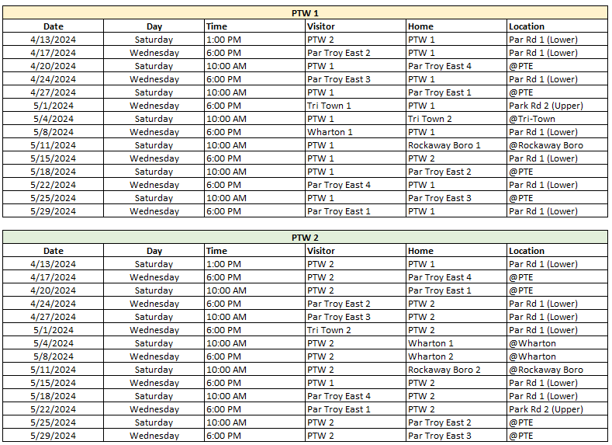

Minor League Softball

Team 1 – Grossi’s Gladiators | Team 2 – Captivate Talent Titans
Mgr: Chris O’Brien | Mgr: Casey Erickson & Niral Desai
Alice McAteer  AlinaMarie Rodriguez  Amelia Donohue  Giuliana Barsanti  Julia Blanche  Kristen Kelly  Maria Cirelli  Melanie Taylor  Reese O’Brien  Samantha Buck  Samantha Alejo  Tess Mauriello | Aanvi Bajaj  Ariana Desai  Giovanna Vielee  Hannah Erickson  Jolie Vallier  Jula Szczepanik  Kadence George  Maya Szczepanik  Riya Gaur  Sarah Nacim  Serna Desai  Sia Kurani

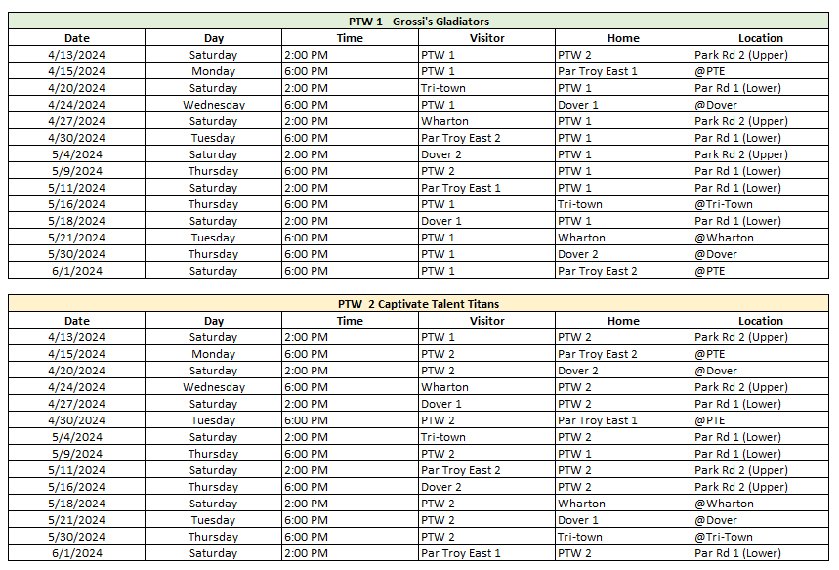
Minor League Softball Schedule

Major League Softball

Team 1 – Counseling Consulting Services of North Jersey | Team 2 – Carifi’s Crusaders
Mgr: Tom Miuccio | Mgr: Matt Millar
Andrea Emma  Avery O’Brien  Caden Riffel  Gabriella Caponigro  Isabella Calabrese  Mallory Hrobuchak  Molly Miuccio  Monica Kopec  Peyton McDermott  Sara Marie Alejo  Savannah Depasquale | Chloe Cuccolo  Gabriella Gencarelli  Isabella Klansky  Kayla Gosselin  Kiera Wittig  Lilah Hutchinson  Maggie Millar  Reese Dolen  Sabrina Galante  Sofia Steuth

Major League Softball Schedule

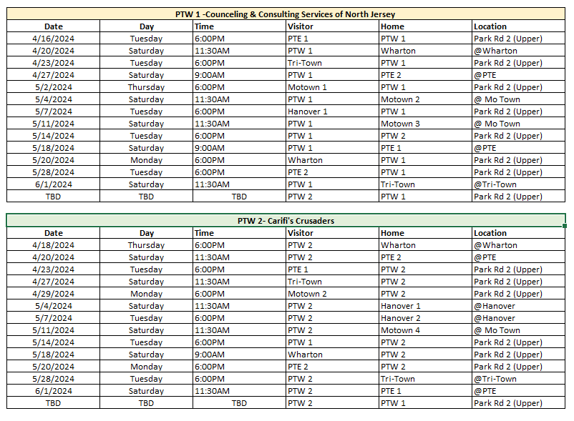

Junior League Softball

Team 1 – Par-Troy East
Liana Nolan

Important Dates and Information to Remember
UPCOMING EVENTS
Saturday May 18th
PICTURE DAY
WHERE: PTWLL Complex (rain – PHHS cafeteria)
TIME: Teams are assigned times – Arrive 15 min. early

Please attend for your team even if you don’t order pictures

Sunday May 19th
MORRIS COUNTY CHALLENGERS DAY
WHERE: PTWLL Complex
TIME: 2:00-4:00 pm (Buddies assist Challengers) and
4:00-6:00 pm (Buddies vs. Challengers)
Come be a buddy for the day and have tons of fun! All ages can help!

June 1st & 2nd
Can shake/Fund drive weekend
WHERE: Various Locations
TIME: 9:00 A.M. to 7 P.M.

REMEMBER TO CHECK THE SPECIAL EVENTS SECTION OF THE WEBSITE

FOR DETAILS AND UPDATES

FOR RAIN OUTS & FIELD CONDITIONS
For our PTWLL Complex | https://partroywestlittleleague.teamsnapsites.com/
For Par-Troy East Complex | Call 973-263-0973
For Town Fields | Visit the webpage http://www.parsippany.net/Departments/Recreation/Fields.aspx
For School/ Board of Education (BOE) Fields | https://sites.google.com/pthsd.net/fieldconditions

Thank You to our Team Sponsors!

T-Ball
Tabor Pizzeria, Super Scoops, Orangetheory, Musella’s Masters, Chick-Fil-, Bagel City Grille

Farm Baseball
Par-Troy Hills Fire Dist. 6, Par-Troy Elks #2078, Neglia’s Nitros, McGrath’s Mashers, Eagle Auto Body, A&L Services

Minor Baseball
Sons of Italy, Ferraro’s, Expert Auto, dePierro’s Defenders, Buffalo Wild Wings, Anthony Franco’s Pizzeria

Major Baseball
JGK Home Improvements, Barberio’s Bombers, Accelerant Sales Group

Junior Baseball
Toyota of Hackensack, Kiwanis of Greater Parsippany

Farm Softball
The Belles, Hernandez’s Hurricanes

Minor Softball
Grossi’s Gladiators, Captivate Talent Titans

Major Softball
Counseling Consulting Services of North Jersey, Carifi’s Crusaders

.

The Little League Pledge

I trust in God
I love my country
And will respect its laws
I will play fair
And strive to win
But win or lose
I will always do my best
Supportive Parents:
- Decrease the pressure to win.
- Believe that the sport's primary value is the opportunity for self development.
- Understand the risks of the sport.
- Communicate their true concerns with the coach.
- Understand and respect the differences between parental roles and coaching roles.
- Control negative emotions and think positively.
- Avoid use of fear.
- Avoid criticism.
- Recognize and understand the expression of insecurity.
- Avoid the use of guilt.
- Show empathy for the young player.

