Par-Troy West Little League

2023 Season Program

Be Proud of Our Children
Be Proud of Our Town
Be Proud of Our League

PTWLL would like to thank the following
Opening Night sponsor for providing the food for opening night:

1057Route 46

Parsippany NJ 07054

973-263-5005

Table of Contents

 | Page #
President’s Message | 4
Board of Directors | 5/6
Our Commitment to Safety | 7
Frequently Asked Questions | 8
Tee Ball League Schedule | 9
Tee Ball League | 10
Farm Baseball League Schedule | 11
Farm Baseball League | 12
Minor League Baseball Schedule | 13
Minor League Baseball | 14
Major League Baseball Schedule | 15
Major League Baseball | 16
Junior League Baseball Schedule | 17
Junior League Baseball | 18
Little League Softball Division | 19
Farm League Softball / Schedule | 20
Minor League Softball | 21
Minor League Softball Schedule | 22
Major League Softball | 23
Major League Softball Schedule | 24
Junior League Softball | 25
Important Information & Events | 26
Team Sponsors | 27
Little League Pledge | 28

President’s Message

Dear Friends of Par-Troy West,

The Board of Directors and I would like to welcome you to the Par-Troy West Little League (PTWLL) Baseball and Softball 2023 Season. This season marks the 70th year that Par-Troy West has had the privilege of serving the children of Parsippany.

Through the 300+ children in our programs combined in both baseball and softball. The Board of Directors continues to work hard and put in many volunteer hours to make sure that your child's experience will be fun filled and enjoyable.

I want to thank all our Board members, volunteers, sponsors and friends, who give their time and support to help make our program run. Without them, we could not operate. It's because of everyone's combined efforts that the Par-Troy West program is such a great success. That is why I and other Board members urge you to please help out and volunteer in any capacity you can. The success of a Little League program depends on the amount of dedicated volunteers we can get to assist.

We would also like to thank the Township of Parsippany, The Parsippany Recreation Department and The Board of Education, for the opportunity to use the ball field in town and at the schools during the season. Their support helps ensure that all Little Leaguers have a place to play.

This coming season should prove to be another exciting one and we look forward to all the children having fun and hope to see you all out there!

Sincerely,

Frank A. Neglia
President
Par-Troy West Little League

WEB Page: https://partroywestlittleleague.teamsnapsites.com/
Par-Troy West Little League

2023 Board of Directors

2023 Executive Board
Name | Official Title | Email
Frank Neglia | President  Corporate Sponsors  Director, Junior/Senior League | partroywest@gmail.com
Darren Dragone | VP Baseball & Administration | dependablemortgage11@gmail.com
Jerry Vecchia | VP Softball/  Equipment & Uniforms | ptwsoftballcoach@gmail.com
Marc Davis | League Treasurer  Purchasing agent/Equipment and Uniforms | midavis03@yahoo.com
Sandra Neglia | Player Agent  Administrator, Sponsors & Trophies/  Umpire Scheduler, / Fund Drive Coordinator  Administrator, Clinics | sandra4a@aol.com
Joelle Rosetti | League Secretary & Information Officer  Webmaster - PTWLL website  Manager, Social Media  Pictures/scheduling, etc. | jojo5er@yahoo.com
Elena Fletcher | Safety Officer  Equipment and Uniforms/Ref. Stand  Softball, Assistant to VP | Efletch73@gmail.com

Board Members
Name | Official Title | Email
Shirley Crane | Director, T-Ball & Farm League Baseball- Equipment & Uniforms | dogsillysuites@gmail.com
Greg Vico | Director, Minor League Baseball  Director, Field Maintenance | gvico24@hotmail
Rich Japko | Director, Major League Baseball/  Scheduler, Batting Cages | Archrej@aol.com
Dave Hutchinson | Softball, Assistant to VP | hutchjd12@yahoo.com
Jessica Becker | Refreshment Stand Coordinator | Snoopychick78@yahoo.com
Nicholas Neglia | Refreshment Stand Coordinator | nickneglia7@gmail.com
Joe Rosetti | League Assistant, Complex Assistant/ Field Maintenance/ | joro1183@yahoo.com
Nick Napolitano | Complex Assistant/ Field Maintenance | Nicknaps2@yahoo.com
Scott Stoveken | Complex Assistant/ Field Maintenance/ Baseball- Equipment & Uniforms | scottystoves@gmail.com
Carmine Verducci | Head Umpire/Umpire Trainer | ckverducci@yahoo.com
Casey Palermo | Refreshment Stand/Uniforms & Equipment  Special Events | Caseypalermo81@gmail.com

Non-Board Member Volunteer (Field and Grounds Maintenance): Paul Breslauer

Our Commitment to Safety
Par-Troy West is committed to providing the safest possible environment for all of our members. The safety of our members and guests continues to be one of our greatest concerns. No organization can truthfully promise an entirely safe environment, especially a youth sports program. Par-Troy West has been a leader, not only in Parsippany Sports programs, but also throughout the Little League District, in implementing responsible Safety Policies. Here are some of the safety policies we have implemented.
- League Volunteer Checking plan submitted to LL District 1 Administrator.
- All PTW Volunteers are required to sign a Volunteer Agreement that includes among its contents authorization to perform a criminal background check.
- League Safety Manual: An extensive PTW-developed publication covering all types of Little League activities. Submitted annually to Little League Inc. for qualified safety program approval.
- Annual audit of facilities submitted with Little League National Facilities Survey.
- All PTW Managers and Coaches are required to:
- Attend a coach's certification, provide proof of certification and be re-certified every three years.
- At least one coach from each team must receive sports-specific First Aid training every year.
- Sign a Coaching Contract that outlines the league expectations.
- Receive, read, support and uphold the PTW League Safety Plan.
- Inspect and remove any damaged or unsafe league equipment.
- All teams are supplied with First Aid Kits, Medical Release forms and Injury Report forms.
- Upgraded league equipment with an aggressive replacement plan.
- Safety bases are used wherever practical.
- Hi-Visibility Fence Edge Protector installed on fields where possible.
- Helmet Chin straps are required for Farm and Minor League Baseball and Softball.
- Helmets with Face Shields are available to teams by request.
- Use of lighting and Severe Storm Warning Device.
- Safety Improvements at the refreshment stand.
- Little League Insurance Program Coverage (described below).

What Parents Should Know About Little League Insurance
Warning: Protective equipment cannot prevent all injuries a player might receive while participating in Baseball/Softball.
The Little League Insurance program is designed to afford protection to all participants at the most economical cost to the local league. It can be used to supplement other insurance carried under a family policy or provided by parent's employer. If there is no coverage, Little League insurance, which is purchased by the league, not the parent, takes over and provides benefits for all covered injury treatment costs up to the maximum stated benefits.
This plan makes it possible for Little League to offer unmatched, low-cost protection with assurance to parents that adequate coverage is in force at all times during the season. If your child sustains a covered injury while taking part in Little League Baseball or Softball, here is how the insurance works:
- File a claim, initially under insurance carried by the family: Blue Cross/Blue Shield or any other insurance protection available.
- Should your family insurance plan not fully cover the injury treatment, the Little League Insurance Policy will help pay the difference up to the maximum stated benefits for all covered injury treatment cost up to the maximum benefits of the policy.
- Treatment of dental injuries can extend beyond the normal 52-week period if dental work must be delayed due to physiological changes of a growing child. Benefits will pay at time treatment is given, even though it may be some years later. Maximum dollar benefit is $500 for eligible deferred dental treatment after the normal 52-week period.
We hope this brief summary has been helpful in better understanding of an important aspect of the operation of the Little League Insurance program.

Frequently Asked Questions About Your Little League

- How is it determined, the level or division in which my child is playing?

While registering, you select a preference of either Softball or Baseball. In addition, the league’s Player Agent uses several criteria to place your child in the appropriate division/team.
  - League Age: The age that a child will be, as of April 30th of the current year for baseball and December 31st of the prior year for softball. League age is used to determine the available options for placement. Leagues are divided by player age, not school grade.
  - Tryouts: Used to help place players at the appropriate skill levels, in addition to helping achieve parity between the teams in a division. Tryouts are not used as criteria until the child becomes League Age of 9 years old.
  - School: Criteria used at the lower levels of play, Tee Ball and Farm Leagues. The Player Agent will try to place children together on teams grouped by the school that they attend, whenever possible. It is important to register early and specify the school to which your child attends.
  - Drafting: Players of League Age eligible for play Softball & Baseball in the Minors, Majors, & Juniors divisions will try out and be drafted by team Managers into teams before the season.

- Does the Township of Parsippany help out with the Little League Complex field maintenance?

Surprisingly, No. The Township of Parsippany and the Parsippany Board of Education both provide permits to use some township fields, which our teams play on. The Complex is owned and completely supported and maintained by the members of PTW Little League. Many hours of volunteer labor go into grooming the fields at the Complex, which are two of the finest in the District. The expenses for maintaining the important building and grounds are raised mainly through refreshment stand proceeds and fund-raising.

- Where does all our registration money go?

All PTW Little League members are encouraged to get involved with the league to have a say in how league funds are budgeted. The Board of Directors meets regularly and the dates of these meetings are posted in the local paper. If you are interested in becoming more involved, please call any of our Executive Board members to find out how. The League is a non-profit organization, chartered by Little League Baseball Inc. Funds raised are put back into the league programs in various ways; equipment, uniforms, maintenance, administration, mailings, rentals, insurances, special events, charter dues, sponsorships, lighting, capital improvements, certifications, safety improvements, Umpires (yes, they are paid), tournament team fees, District support, to name a few. Directors are volunteers and are not compensated for their services.

- Why does Little League have so many rules?

Admittedly, Little League has many rules. For some, the value is not easily seen. But, remember that Little League is a worldwide organization. As members, we are expected to support the rules and values of the National Little League Organization. The rules and some local rules, though at times appearing petty, are essential to maintaining the standards and image of Little League in our area and abroad. Little League is a respected model for many other organizations and its continued integrity is due to, in great part, the loyalty, conformance and passion of its members.

WEB Page: https://partroywestlittleleague.teamsnapsites.com/

T-Ball League Schedule

Team 1 | Bagel City Grille | Team 4 | Eagle Auto Body
Team 2 | Super Scoops | Team 5 | Musell’s Masters
Team 3 | Parsippany Fuel | Team 6 | P-T Hills Fire District #6

MAY
Date | Day | Time | Home | Away | Field
5/2 | Tue | 6:00 | 1 | 2 | CF
5/2 | Tues | 6:00 | 6 | 3 | CK
5/3 | Wed | 6:00 | 5 | 4 | CK
5/6 | Sat | 11:00 | 4 | 3 | CK
5/6 | Sat | 1:00 | 1 | 6 | CK
5/6 | Sat | 3:00 | 5 | 2 | CK
5/8 | Mon | 6:00 | 4 | 6 | CK
5/11 | Thu | 6:00 | 5 | 1 | DF
5/11 | Thu | 6:00 | 3 | 2 | CK
5/13 | Sat | 9:00 | 1 | 4 | CF
5/13 | Sat | 11:30 | 3 | 5 | DF
5/13 | Sat | 3:00 | 2 | 6 | CK
5/18 | Thu | 6:00 | 6 | 5 | CF
5/18 | Thu | 6:00 | 1 | 3 | DF
5/18 | Thu | 6:00 | 2 | 4 | CK
5/20 | Sat | 9:00 | 2 | 1 | CF
5/20 | Sat | 2:00 | 4 | 5 | DF
5/20 | Sat | 3:00 | 3 | 6 | CK
5/23 | Tue | 6:00 | 3 | 4 | CK
5/24 | Wed | 6:00 | 6 | 1 | CK
5/25 | Thu | 6:00 | 2 | 5 | CK
5/31 | Wed | 6:00 | 6 | 4 | CK
CF-Carroll Field / DF- Directors Field / CK-Cook Field (all PTWLL Baseball Complex)
LF-Littleton School Front / LPP-Lk. Parsippany Park

APRIL
Date | Day | Time | Home | Away |  | Field
4/15 | Sat | 9:00 | 2 | 1 |  | CK
4/15 | Sat | 11:00 | 3 | 6 |  | CK
4/15 | Sat | 1:00 | 4 |  | 5 | CK
4/18 | Tue | 6:00 | 3 |  | 4 | CK
4/19 | Wed | 6:00 | 6 |  | 1 | CK
4/20 | Thu | 6:00 | 2 |  | 5 | CK
4/22 | Sat | 9:00 | 2 |  | 3 | CK
4/22 | Sat | 2:00 | 6 |  | 4 | DF
4/22 | Sat | 2:00 | 1 |  | 5 | LPP
4/25 | Tue | 6:00 | 4 |  | 1 | CK
4/26 | Wed | 6:00 | 5 |  | 3 | CF
4/27 | Thu | 6:00 | 6 |  | 2 | CK
4/29 | Sat | 9:00 | 5 |  | 6 | CK
4/29 | Sat | 11:00 | 1 |  | 3 | CK
4/29 | Sat | 1:00 | 4 |  | 2 | CK

JUNE
Date | Day | Time | Home | Away | Field
6/1 | Thu | 6:00 | 2 | 3 | DF
6/1 | Thu | 6:00 | 1 | 5 | CK
6/3 | Sat | 9:00 | 5 | 3 | CK
6/3 | Sat | 2:00 | 4 | 1 | LPP
6/3 | Sat | 2:00 | 6 | 2 | DF
6/5 | Mon | 6:00 | 5 | 6 | DF
6/7 | Wed | 6:00 | 1 | 3 | CK
6/8 | Thu | 6:00 | 4 | 2 | CK
6/10 | Sat | 9:00 | 1 | 2 | CF
6/10 | Sat | 9:00 | 3 | 4 | DF
6/10 | Sat | 9:00 | 5 | 6 | CK

Tee Ball League

Team 1 – Bagel City Grille | Team 2: Super Scoops | Team 3: Parsippany Fuel
Mgr: John Ihne  Coach: Steven Sergio  Coach: Rich Weng  Coach: Christopher Maass | Mgr: Jesse Miller  Coach: Chris Berretta | Mgr: Rich Komissar  Coach: Rob Vesper  Coach: Arthur Stawski  Coach: Paul Gardyasz
Aaron Chapin  Alexandra Weng  Alison Maass  Asher Romano  Cody DeOliveira  Cooper Sheffield  Dominic Sergio  Evan Amerman-McGrath  Jacob Nunn  John Ihne  Olivia Witek  Zachary Cocchi | Abigail Berretta  Dylan Erickson  Alfred Proto  Andrew Langford  James Stabler  Jayden Tam  Nicholas Radulic  Owen Donohue  Ray LeBlanc  Ryan Miller | Adelaide Vesper  Ella Halbach  Emily Gardyasz  Emma Klansky  Everett Vesper  Hans Patel  Jonathan Stawski  Robert Poplawski  Sofia Komissar  Xavier Arturi
Team 4 – Eagle Auto Body | Team 5 – Musella’s Masters | Team 6 – Fire District #6
Mgr: Chris O’Brien  Coach: Frank Imbriaco  Coach: Christine Judge  Coach: Allison O’Brien | Mgr: Jonathan Starr  Coach: Jeff Starr  Coach: Brendan Higgins | Mgr: Brian Vohs  Coach: John Otte  Coach: Brielle Pardon
Adrianna Vielee  Brooke O’Brien  Derek Imbriaco  Joseph Imbriaco  Giuseppe Talerico  John Toner  Karn Pathak  Matthew Nacim  Ricky Rodriguez  Selynabh Bilbao La Vieja | Alexa Calle  Anthony Loughlin  Daniel Nekulak  Emersyn Fontan-Clark  Emma Matarazzo  Hailey Higgins  Kabir Pathak  Mateya Starr  Olivia Starr | Adriana Shivers  Andi Pardon  Andrew Otte  Christian De Jesus  Damen Pardon  Dean Ianco  Lucas Vohs  Mason Stewart  Mathew Figaro

Farm Baseball League Schedule

Team 1 | Neglia’s Nitros | Team 4 | Tabor Pizzeria
Team 2 | Hennion & Walsh | Team 5 | Sons of Italy
Team 3 | JCK Home Improvements | Team 6 | Expert Auto

Field Codes: | CK – Cook Field | LF – Littleton School Front | DF-Directors Field | CF- Carroll Field
LPP-Lake Parsippany Park
MAY
Date | Day | Time | Home | Away | Field
5/1 | Mon | 6:00 | 1 | 2 | CF
5/1 | Mon | 6:00 | 6 | 3 | DF
5/1 | Mon | 6:00 | 5 | 4 | CK
5/6 | Sat | 9:00 | 5 | 2 | CK
5/6 | Sat | 2:00 | 4 | 3 | LLP
5/6 | Sat | 2:00 | 1 | 6 | DF
5/8 | Mon | 6:00 | 4 | 6 | CF
5/9 | Tue | 6:00 | 3 | 2 | DF
5/9 | Tue | 6:00 | 5 | 1 | CK
5/13 | Sat | 9:00 | 1 | 4 | CK
5/13 | Sat | 11:00 | 3 | 5 | CK
5/13 | Sat | 1:00 | 2 | 6 | CK
5/15 | Mon | 6:00 | 6 | 5 | CK
5/16 | Tue | 6:00 | 3 | 1 | CK
5/17 | Wed | 6:00 | 2 | 4 | CK
5/20 | Sat | 9:00 | 3 | 6 | CK
5/20 | Sat | 11:00 | 2 | 1 | CK
5/20 | Sat | 1:00 | 4 | 5 | CK
5/22 | Mon | 6:00 | 3 | 4 | CK
5/24 | Wed | 6:00 | 6 | 1 | DF
5/25 | Thu | 6:00 | 2 | 5 | DF
5/30 | Tue | 6:00 | 6 | 4 | CF
5/30 | Tue | 6:00 | 2 | 3 | CK

JUNE
Date | Day | Time | Home | Away | Field
6/1 | Thu | 6:00 | 1 | 5 | CF
6/3 | Sat | 11:00 | 4 | 1 | CK
6/3 | Sat | 1:00 | 5 | 3 | CK
6/3 | Sat | 3:00 | 6 | 2 | CK
6/5 | Mon | 6:00 | 5 | 6 | CK
6/6 | Tue | 6:00 | 1 | 3 | CK
6/6 | Tue | 6:00 | 4 | 2 | LPP
6/10 | Sat | 11:00 | 1 | 2 | CK
6/10 | Sat | 1:00 | 3 | 6 | CK
6/10 | Sat | 3:00 | 4 | 5 | CK
6/12 | Mon | 6:00 | 3 | 4 | CK
6/13 | Tue | 6:00 | 6 | 1 | CK
6/14 | Wed | 6:00 | 2 | 5 | CK

APRIL
Date | Day | Time | Home | Away |  | Field
4/15 | Sat | 9:00 | 2 | 1 |  | CF
4/15 | Sat | 9:00 | 4 | 5 |  | DF
4/15 | Sat | 11:00 | 3 | 6 |  | CF
4/17 | Mon | 6:00 | 3 |  | 4 | CK
4/18 | Tue | 6:00 | 6 |  | 1 | CF
4/19 | Wed | 6:00 | 2 |  | 5 | DF
4/22 | Sat | 11:00 | 6 |  | 4 | CK
4/22 | Sat | 1:00 | 2 |  | 3 | CK
4/22 | Sat | 3:00 | 1 |  | 5 | CK
4/24 | Mon | 6:00 | 4 |  | 1 | CK
4/25 | Tues | 6:00 | 5 |  | 3 | DF
4/27 | Thu | 6:00 | 6 |  | 2 | DF
4/29 | Sat | 9:00 | 5 |  | 6 | CF
4/29 | Sat | 11:30 | 1 |  | 3 | DF
4/29 | Sat | 3:00 | 4 |  | 2 | CK

*Any games scheduled or rescheduled on Carroll Field or Directors will have a 2-hour time limit.

Farm Baseball League

Team 1: Neglia’s Nitros | Team 2: Hennion & Walsh | Team 3: JCK Home Improvements
Mgr: Devin Cavaleri  Coach: Josh Winner  Coach: Chris McDermott  Coach: Jason Paniccia | Mgr: John Wallace  Coach: Beau Worley  Coach: Kellie Andersen  Coach: Vin Cooper | Mgr: Steve Hernandez  Coach: Colin Badini  Coach: Justin Vallier
Aaron Skomial  Alexander Roman  Charle McDermott  Cole Paniccia  Colton Cavaleri  Ethan Paniccia  Jacob Paniccia  Joseph Raffaele Gencarelli  Luke Beltran  Maverick Winner | Ashneel Kumar  Caiden Walski  Hudson Halbach  Jayson Bromley  Landon Wallace  Maddox Worley  Ryan Cooper  Sawyer Andersen  Vivan Bhattacharya  Zachary Lopez | Alexander Babadjanov  Anthony Richards  Brian Hernandez  Caius Badini  Carter Martinez  Joseph Vallier  Kahaan Pujara  Lincoln Arriaza  Lleyton Fontan-Clark  Neel Patel  Ryden Bohorquez
Team 4 – Tabor Pizzeria | Team 5 – Sons of Italy | Team 6 – Expert Auto
Mgr: Tim King  Coach: Fred Maltino | Mgr: Jeff Hardgrove  Coach: Pat McCarthy  Coach: Paul Silva  Coach: Jeff Rhinesmith | Mgr: Jeff Gallagher  Coach: John Starr  Coach: Ken Yuen
Alex Gutierrez  Bennett Troup  Carter Simansky  Conor King  Dylan Romano  Jacob Nicholas  Jacob Becker  Liam Fitzpatrick  Michael Maltino  Shiv Parmar  Tristan Sopko | Aarav Patel  Adnan Amara  Avi Patel  Conner Rhinesmith  Derrick Berta  Dylan Hardgrove  Dylan Digirolamo  Hudson McCarthy  Jack Miller  John Kilpatrick  Leo Silva  Vihan Patel | Elijah Calle  Henry Leslie  Jackson Wu  Koen Yuen  Luke Gallagher  Mason Gonell  Nathan Starr  Samarth Thumar  Thomas Cortezano  Tyler Barrows

Minor League Baseball Schedule

Team 1 | dePierro's Defenders | Team 4 | Anthony Franco’s Pizza
Team 2 | Ferrara’s | Team 5 | Parsippany Fuel
Team 3 | Expert Auto
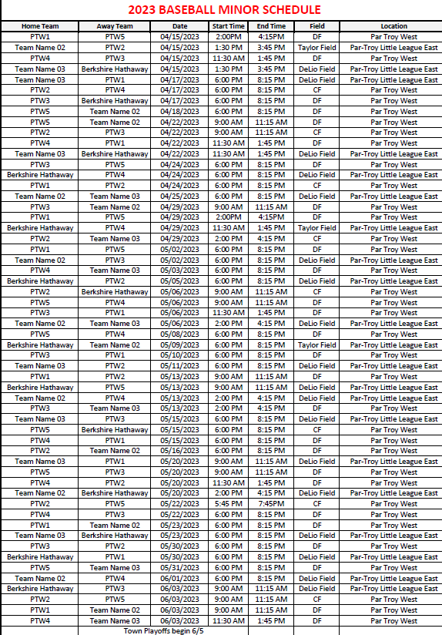
Field Codes:-  D-PTE field DeLio | DF-Directors Field | CF – Carroll Field T-PTE field Taylor

Minor League Baseball
Team 1: dePierro’s Defenders | Team 2: Ferrara’s | Team 3: Expert Auto
Mgr: Josh Winner  Coach: Jim Beadle | Mgr: Nick Guida  Coach: Andrew Naumann | Mgr: Joe Rosetti  Coach: Rob Digirolamo  Coach: Joelle Rosetti
Alexander Kopec  Austin Craney  Brennan Beadle  Colin Lewis  Dean Velez  Derreck Bracken  Jameson Ledyard  Leo Ferrara  Luca Branda  Luke Winner  Saahil Desai | Aidan Amerman-McGrath  Aiden Fox  Andrew Shivers  Dominick Naumann  Jaxson Egarian  Joseph Panuccio  Josh Dorcely  Nicky Guida  Rowen Dunn  Theo Dunn  Theodore Colonna  Vihan Vadher | Arthur Smith  Charlie Cevasco  Jesse George  Liam Steuth  Logan Digirolamo  Owen Petofi  Ricki Rosetti  Samuel Perez  Tyler Hardgrove  Wyatt Seabury
Team 4 – Anthony Franco’s Pizza | Team 5 – Parsippany Fuel
Mgr: Pete Kaczorowski | Mgr: Shirley Meo-Crane  Coach: Matt Millar
Ari Modi  Connor Kaczorowski  Gabriel Beltran  Matthew Freund  Matthew Langford  Michael Caponigro  Nicholas Roman  Rohan Bhatt  Roman Skomial  Ryan Pierzynski  Samuel Becker | Christopher Matacotta  Eli Quintero  Eoin Millar  Hudson Handler  Jack Cavanaugh  Liam Chevalier  Noah Meo-Crane  Oliver Troup  Richie Komissar  Ryan Cascante  Ryan Shah  Tommy Buraszeski

Major League Baseball Schedule

Team 1 | Barberio’s Bombers
Team 2 | Dog Silly Suites
Team 3 | Toyota of Hackensak

Field Codes: | CF-Carroll Field | PTE-PTE Fields
W-Wharton

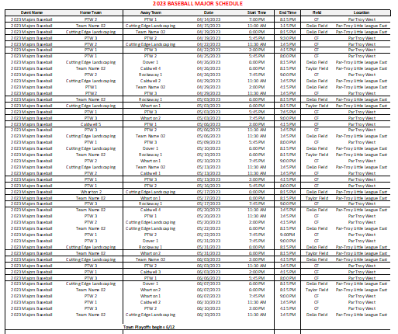

Major League Baseball

Team 1: Barberio’s Bombers | Team 2: Dog Silly Suites
Mgr: Raj Ramani  Coach: Brian Brosnan  Coach: Anthony Gonzalez | Mgr: Shirley Meo-Crane  Coach: Andrew Sabatini  Coach: Mark Marchaterre
Alec Paquette  Alex Gonzalez  Antonio Gonzalez  Chrystian Bouman  Connor DeVitto  Ohm Patel  Padraig Beadle  Patrick Brosnan  Rohit Khubchandani  Samarth Joshi  Sandler Ros  Shriraj Ramani | Aarya Trambadiya  Callan Marchaterre  Julian Ledesma  Kayan Vadher  Landon Kaszner  Liano Bisceglia  Matteo Lombardi  Matthew Martinez  Nichael Gonnella  Stephen Meo-Crane  Thomas Tafro  Tyler Sabatini
Team 3 – Toyota of Hackensack
Mgr: Scott Stoveken
Coach: Greg Vico
Coach: Himanshu Tailor

Caleb Ibanga
Daniel Kelly
Declan Schulze
Evan Colonna
Greg Vico
Jayson Tailor
Joseph Radulic
Mason Stoveken
Matthew Radulic
Michael Cocchi
Nicholas Fraga
Shaurya Bhatnagar

Junior League Baseball Schedule

Team 1 | Parsippany Elks #2078
Team 2 | A-L Service

Date: | Teams: |  | Date: | Teams:
Monday 4/17 | Elm St @ Ryan Plumbing & Heating |  | Friday  5/12 | A&L Services @ Elks #2078
 | Hanover @ East Hanover
 |  |  | Monday 5/15 | A&L Services @ East Hanover
Wednesday 4/19 | Elks #2078 @ Elm St |  |  | Hanover @ Elm St
 | A&L Services @ Columbia Bank
 |  |  | Wednesday  5/17 | Columbia Bank @ Elks #2078
Friday  4/21 | Hanover @ A&L Services @ Columbia Bank |  |  | Ryan Plumbing & Heating @ Elm St
Monday 4/24 | Hanover @ Columbia Bank |  | Friday  5/19 | Hanover @ Ryan Plumbing & Heating
 | Elks #2078 @ A&L Services |  |  | Columbia Bank @ A&L Services
Wednesday 4/26 | East Hanover @ A&L Serivices  Elks #2078 @ Columbia Bank |  | Monday 5/22 | East Hanover @ Hanover
 |  |  |  | Elks2078 @ Ryan Plumbing & Heating
Friday  4/28 | Elm St. @ Hanover
 | Ryan Plumbing & Heating @ East Hanover |  | Wednesday  5/24 | East Hanover @ Ryan Plumbing & Heating
 |  |  |  | Columbia Bank @ Elm St.
Monday 5/01 | Columbia Bank @ East Hanover
 | A&L Services @ Hanover |  | Wednesday  5/31 | East Hanover @ Columbia Bank
 |  |  |  | Elm St. @ A&L Services
Wednesday 5/3 | Ryan Plumbing & Heating @ A&L Services
 | Elks #2078 @ East Hanover |  | Friday  6/2 | Ryan Plumbing & Heating @ Hanover
 |  |  |  | East Hanover @ Elks #2078
Friday  5/5 | Elm St @ Columbia Bank
 | Hanover @ Elks #2078 |  | Monday  6/5 | Elm St @ Elks #2078
 |  |  |  | Columbia Bank @ Hanover
Monday  5/8 | Columbia Bank @ Ryan Plumbing & Heating
 | East Hanover @ Elm St. |  | Wednesday 6/7 | Ryan Plumbing & Heating @ Columbia Bank
 |  |  |  | Elm St. @ East Hanover
Wednesday 5/10 | A&L Services @ Elm St |  | Friday  6/9 | Elks #2078 @ Hanover
 |  |  |  | A&L Services @ Ryan Plumbing & Heating

Junior/Senior League Baseball

Team 1: Parsippany Elks #2078 | Team 2: A-L Services
Mgr: Joe Roman  Coach: Paul Silva | Mgr: Frank Yany Jr.  Coach: Mike Cirelli
Alex Matacotta  Ansh Patel  Christopher Roman  Damon Silva  Deven Martino  Logan Martell  Mario Guerriero  Nathaniel Hayes  Neil Bhatt  Patrick Donaldson | Andrew Dollard  Anthony Cirelli  Evan Ibanga  Frank Yany III  Franklin Novitskie  Gabriel Becker  Jai Upadhyay  Jake Schulze  Jaylen Crawford  Marc Becker  Thomas Romaine

Little League

Softball Division

Farm League Softball

Team 1 – The Belles | Team 2 – Gragnani’s Gladiators
Mgr: Christine Fox | Mgr: Jesse George  Coach: Niral Desai
Adalyn Fox  AlinaMarie Rodriguez  Anna Panuccio  Claire Poplawski  Emma Wyman  Farrah Egarian  Juliana Silva  Liliana Silva  Mia Castellano  Mia Algieri  Sophia Guida  Tess Mauriello | Adelynn Fontan-Clark  Gabriella Avoletta  Julia Szczepanik  Kadence George  Maya Szczepanik  Samantha Alejo  Savannah Weng  Serena Desai

Farm League Softball Schedule

PTW1 – The Belles | PTW2 – Gragnani’s Gladiators

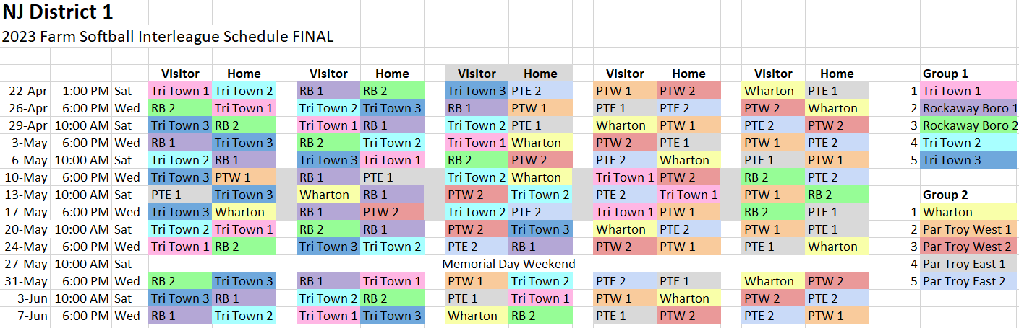

Minor League Softball

Team 1 – Orangetheory Fitness | Team 2 – Grossi’s Gladiator’s
Mgr: Tom Miuccio  Coach: Chris McDermott  Coach: Chris O’Brien  Coach: Dan Matos | Mgr: Casey Erickson  Coach: Niral Desai  Coach: Jenna Matthews  Coach: Valay Desai  Coach: Alok Guar  Coach: Nitin Bajaj  Coach: Mike Erickson
Clara Paniccia  Emma Matos  Giuliana Barsanti  Isabella Calabrese  Isobel Cope-Morgan  Jory Cavaleri  Julia Blanche  Mallory Hrobuchak  Mia Cappuccino  Molly Miuccio  Peyton McDermott  Reese O’Brien  Samantha Buck  Sarah Nacim | Aanvi Bajaj  Anika Desai  Ariana Desai  Ava Kevorkian  Charlotte Hughes  Gabriella Caponigro  Giovanna Vielee  Hannah Erickson  Kristen Kelly  Maria Cirelli  Melanie Taylor  Riya Gaur  Sia Kurani  Siya Desai

Minor League Softball Schedule

PTW1 – OrangeTheory Fitness
PTW 2 – Grossi’s Gladiators

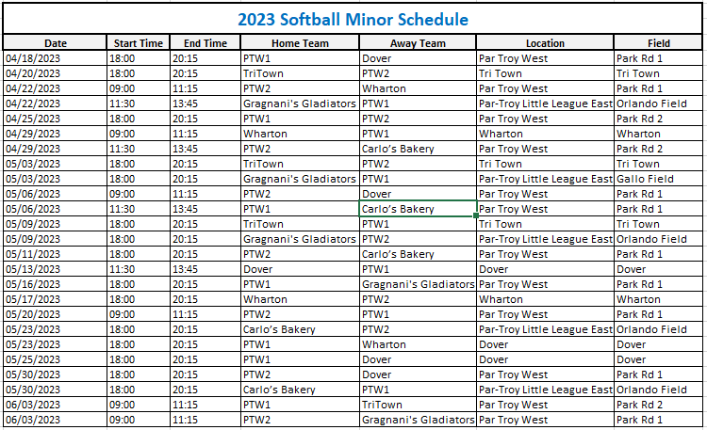

Major League Softball

Team 1 – Carifi’s Crusaders | Team 2 – Expert Auto
Mgr: Dave Hutchinson  Coach: Dave Cuccolo  Coach: Chris O’Brien | Mgr: Matt Millar  Coach: Rob Gosselin  Coach: Mike Wilson
Avery O’Brien  Caden Riffel  Chloe Cuccolo  Daniela Bracken  Gabriella Gencarelli  Isabella Klansky  Kiera Wittig  Lilah Hutchinson  Reese Dolen  Sabrina Galante  Sara Marie Alejo  Sofia Steuth  Willow Olstad | Andrea Emma  Chloe Wu  Courtney Terrone  Kathryn Cischke  Kayla Gosselin  Kelsey Snellings  Macie Wilson  Maggie Millar  Monica Kopec  Savannah Depasquale  Sienna Colio  Sophia Venturini

Major League Softball Schedule

PTW1 – Expert Auto |  | PTW2- Carifi’s Crusaders

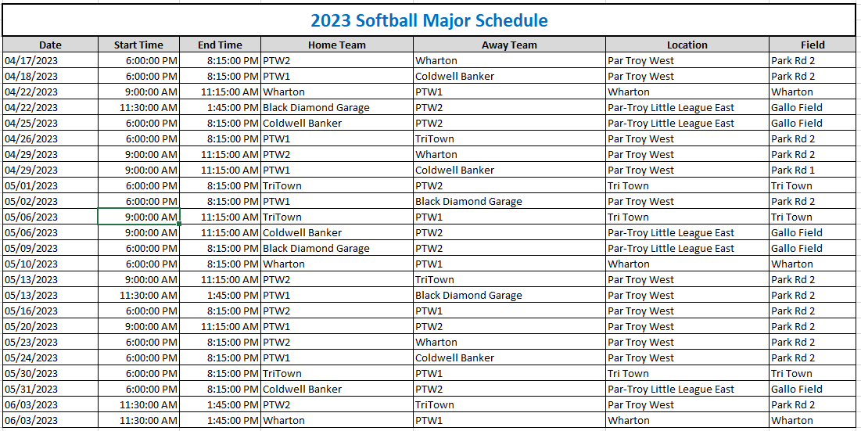

Team 1 – Par-Troy East
Mgr:

Alexandra Romaine
Anya Gaur
Ava Tahiri
Izabel Glickman
Liana Nolan

Important Dates and Information to Remember
UPCOMING EVENTS
May 20 ~ Saturday
PICTURE DAY
WHERE: PTWLL Complex (rain – PHHS cafeteria)
TIME: Teams are assigned times – Arrive 15 min. early

Please attend for your team even if you don’t order pictures

May 7 ~ Sunday
MORRIS COUNTY CHALLENGERS DAY
WHERE: PTWLL Complex
TIME: 2:00-4:00 pm (Buddies assist Challengers) and
4:00-6:00 pm (Buddies vs. Challengers)
Come be a buddy for the day and have tons of fun! All ages can help!

June 2-4
Can shake/Fund drive weekend
WHERE: Various Locations
TIME: 9:00 A.M. to 7 P.M.

REMEMBER TO CHECK THE NEWS & EVENTS SECTION OF THE WEBSITE

FOR DETAILS AND UPDATES

FOR RAIN OUTS & FIELD CONDITIONS
For our PTWLL Complex | TeamSnap Updates
For Par-Troy East Complex | Call 973-263-0973
For Town Fields | Visit the webpage http://www.parsippany.net/Departments/Recreation/Fields.aspx
For School/ Board of Education (BOE) Fields | https://sites.google.com/pthsd.net/fieldconditions

Thank You to our Team Sponsors!

T-Ball
Super Scoops, Parsippany Fuel, Musella’s Masters, Eagle Auto Body, Bagel City Grille,
Parsippany Troy-Hills Fire District #6

Farm Baseball
Tabor Pizza, Sons of Italy, JCK Home Improvements, Neglia’s Nitros, Expert Auto, Hennion & Walsh

Minor Baseball
Parsippany Fuel, Ferraro’s, Expert Auto, diPierro’s Defenders, Anthony Francos Pizza

Major Baseball
Toyota of Hackensack, Barberio’s Bombers, Dog Silly Suites

Junior Baseball
Parsippany Elks #2078, A-L Services

Farm Softball
The Belles, Graganis Gladiators

Minor Softball
Orangetheory Fitness, Grossi’s Gladiators

Major Softball
Expert Auto, Carifi’s Crusaders

Junior Softball
Par-Troy West / Par-Troy East

.

The Little League Pledge

I trust in God
I love my country
And will respect its laws
I will play fair
And strive to win
But win or lose
I will always do my best
Supportive Parents:
- Decrease the pressure to win.
- Believe that the sport's primary value is the opportunity for self development.
- Understand the risks of the sport.
- Communicate their true concerns with the coach.
- Understand and respect the differences between parental roles and coaching roles.
- Control negative emotions and think positively.
- Avoid use of fear.
- Avoid criticism.
- Recognize and understand the expression of insecurity.
- Avoid the use of guilt.
- Show empathy for the young player.

